**Assignment 3 (DB)**

**Diyan Saeed**

**L1F21BSCS0783**

**D11**

a)

SELECT *

FROM EMPLOYEE

WHERE Dno = 4;

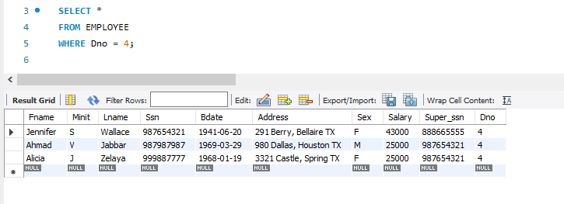

b)

SELECT *

FROM EMPLOYEE

WHERE Salary > 30000;

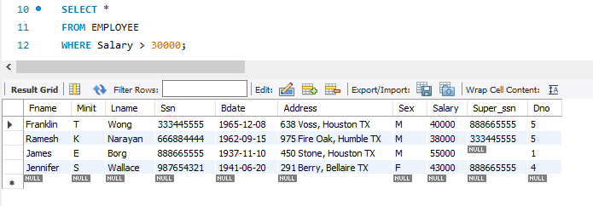

c)

SELECT * FROM EMPLOYEE

WHERE (Dno = 4 AND Salary > 25000) OR (Dno = 5 AND Salary > 30000);

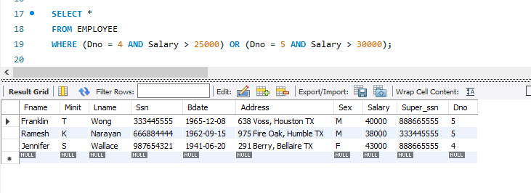

d)

SELECT Fname, Lname, Salary

FROM EMPLOYEE;

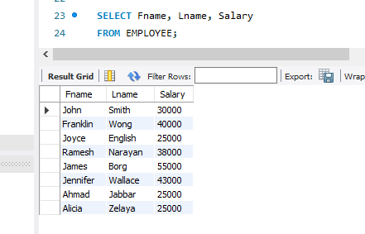

e)

SELECT Sex, Salary

FROM EMPLOYEE;

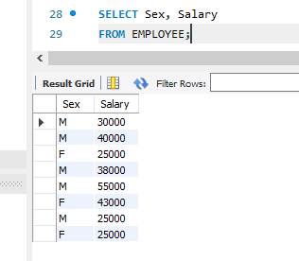

f)

SELECT Fname, Lname, Salary

FROM EMPLOYEE

WHERE Dno = 5;

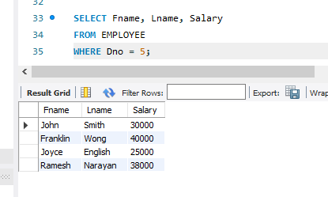

g)

SELECT DISTINCT E.Ssn

FROM EMPLOYEE E

LEFT JOIN EMPLOYEE S ON E.Ssn = S.Super_ssn

WHERE E.Dno = 5 OR S.Dno = 5;

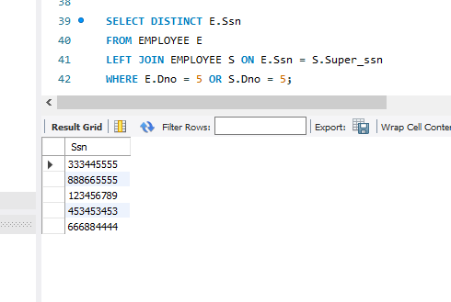

h)

SELECT E.Ssn

FROM EMPLOYEE E

JOIN EMPLOYEE S ON E.Ssn = S.Super_ssn

WHERE E.Dno = 5 AND S.Dno = 5;

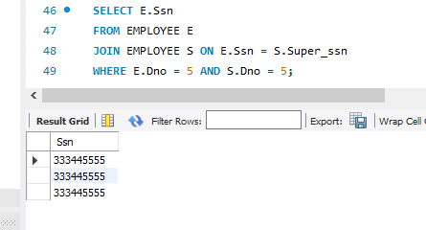

i)

SELECT DISTINCT E.Ssn

FROM EMPLOYEE E

JOIN EMPLOYEE S ON E.Ssn = S.Super_ssn

WHERE E.Dno != 5 AND S.Dno = 5;

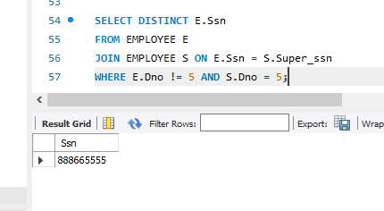

j)

SELECT E.Fname AS Employee_FirstName, E.Lname AS Employee_LastName, D.Dependent_name

FROM EMPLOYEE E

JOIN DEPENDENT D ON E.Ssn = D.Essn

WHERE E.Sex = 'F';

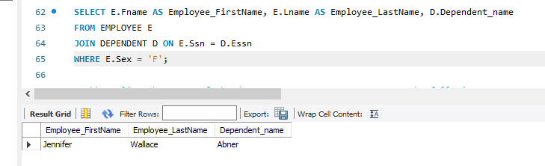

k)

SELECT E.Fname AS Manager_FirstName, E.Lname AS Manager_LastName

FROM EMPLOYEE E

JOIN DEPARTMENT D ON E.Ssn = D.Mgr_ssn;

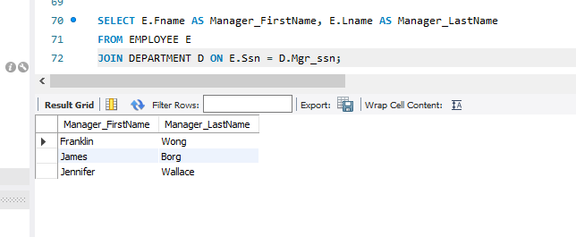

l)

SELECT P.Pname AS Project_Name, D.Dname AS Department_Name

FROM PROJECT P

JOIN DEPARTMENT D ON P.Dnum = D.Dnumber;

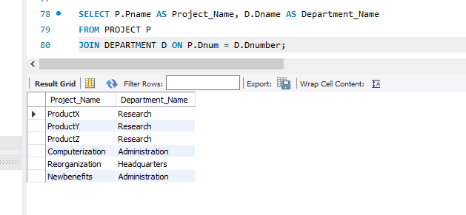

m)

SELECT E.Fname, E.Lname

FROM Employee E

WHERE E.SSN IN (

SELECT W.SSN

FROM Works_On W

WHERE W.Pno NOT IN (

SELECT P.Pnumber

FROM Project P

WHERE P.Dnum = E.Dno

)

);

n)

SELECT E.Fname, E.Lname, E.Sex, E.Salary

FROM EMPLOYEE E

WHERE E.Super_ssn = (

SELECT S.Ssn

FROM EMPLOYEE S

WHERE S.Fname = 'Jennifer' AND S.Lname = 'Wallace'

);

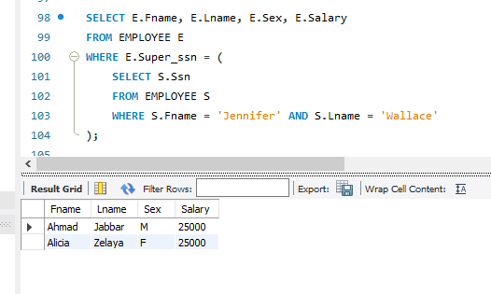

o)

SELECT E.Fname, E.Lname

FROM EMPLOYEE E

WHERE E.Dno = (

SELECT D.Dnumber

FROM DEPARTMENT D

WHERE D.Locations = 'Houston'

) AND E.Job = 'Manager';

p)

SELECT E.Fname, E.Lname, E.Salary

FROM Employee E

WHERE E.SSN IN (

SELECT D.ESSN

FROM Dependent D

WHERE D.Sex = 'F'

);

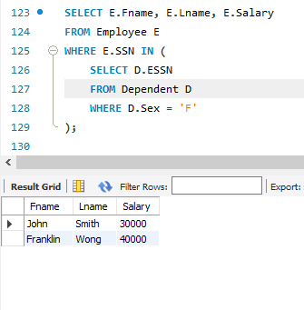

q)

SELECT E.Fname, E.Lname, E.Salary

FROM EMPLOYEE E

WHERE EXISTS (SELECT * FROM DEPENDENT D

WHERE D.Essn = E.Ssn AND D.sex = E.Sex);

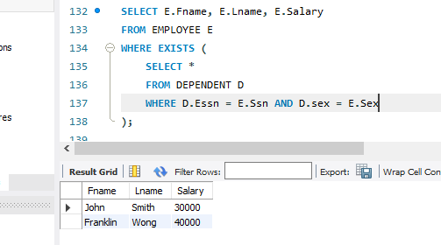

r)

SELECT AVG(Salary) AS AverageSalary

FROM EMPLOYEE

WHERE Sex = 'F';

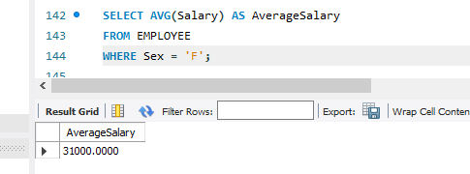

s)

SELECT Fname, Lname, Sex, Salary

FROM EMPLOYEE

WHERE Salary > (

SELECT AVG(Salary)

FROM EMPLOYEE

WHERE Sex = 'F');

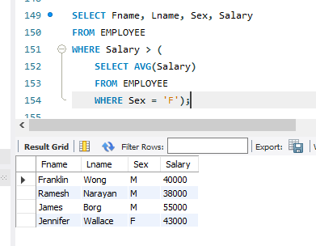

t)

SELECT D.Dname AS DepartmentName, AVG(E.Salary) AS AverageSalary

FROM DEPARTMENT D

JOIN EMPLOYEE E ON D.Dnumber = E.Dno

GROUP BY D.Dname;

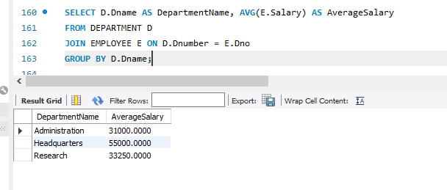

u)

SELECT Fname, Lname

FROM EMPLOYEE

WHERE Ssn NOT IN (SELECT Essn FROM DEPENDENT);

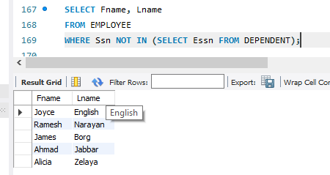

v)

SELECT E.Fname, E.Lname, E.Salary, SUM(W.Hours) AS TotalHours

FROM EMPLOYEE E

JOIN WORKS_ON W ON E.Ssn = W.Essn

GROUP BY E.Fname, E.Lname, E.Salary;

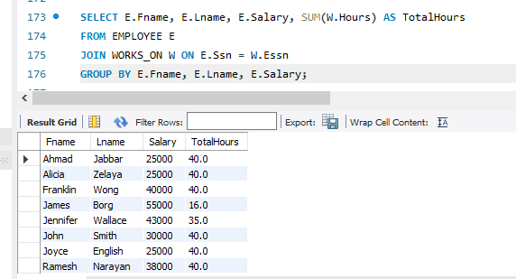

w)

SELECT E.Fname, E.Lname, E.Salary, SUM(W.Hours) AS TotalHours

FROM EMPLOYEE E

JOIN WORKS_ON W ON E.Ssn = W.Essn

GROUP BY E.Fname, E.Lname, E.Salary

HAVING TotalHours < 20;

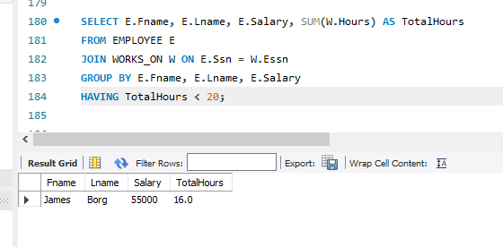

x)

SELECT E.Fname, E.Lname, E.Salary

FROM EMPLOYEE E

WHERE

( SELECT COUNT(*)

FROM DEPENDENT D

WHERE D.Essn = E.Ssn ) >= 2;

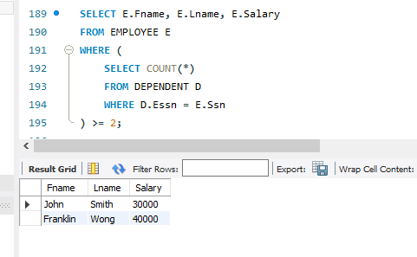

y)

SELECT E.Fname, E.Lname

FROM EMPLOYEE E

JOIN DEPARTMENT D ON E.Ssn = D.Mgr_ssn

WHERE EXISTS (

SELECT *

FROM DEPENDENT DEP

WHERE DEP.Essn = E.Ssn

);

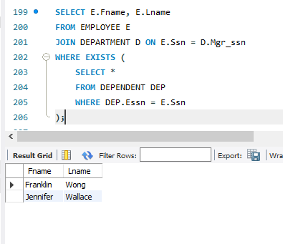

z)

SELECT E.Fname, E.Lname, E.Salary, COUNT(D.Essn) AS TotalDependents

FROM EMPLOYEE E

LEFT JOIN DEPENDENT D ON E.Ssn = D.Essn

GROUP BY E.Fname, E.Lname, E.Salary;

